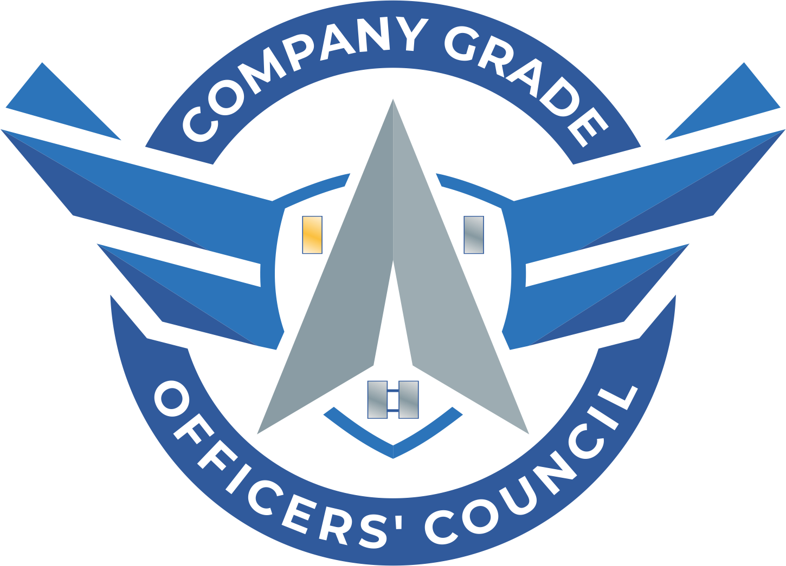

**CGOC Lessons Learned**

**Started May 2022**

**Lt Laura C. Lanier**

Opening 2

Council Priorities 2

On Leadership 3

# Opening

The below is a list of lessons learned I came up with after my year as Dover’s CGOC president. Some of these are things our council did well, and others are things I wish we would’ve done differently. I’ve also gotten inputs from other CGOC presidents to compile a comprehensive list of helpful tips and tricks. Every CGOC is different, so take what works and make it your own!

# Council Priorities

* You can survey a few of your folks, but also remember to lead from the front and set priorities that you can manage and delegate
* Determine Council priorities based on easy wins and long-term projects
* Easy wins: Speaker series/Panel discussion with base leadership; Volunteer with base-wide program; Support FFIT
* Long-term projects: 5k mud run; DAF speaker series/panel discussion; Fundraisers
* Start the year with a Fiscal Plan. This can include:
* Fundraising goals for the year. Map out what fundraisers you want to do and how much you expect to raise from each one. Then, get them routing through legal and your base’s PO liaison ASAP.
  + Donation Plan. How much do you want to donate to other orgs/events for the year? Do you have guidelines about who you will donate to? Will people requesting support need to fill out a form, or just ask?
  + Make sure bank account info is updated with the current treasurer and president.
* Start a CGO group chat! (GroupMe, Whatsapp, Slack, etc.) This is by far the best way we found to communicate.
* Set a consistent meeting schedule and stick to it. We met as a CGOC the third Friday of every month. It might sound weird, but we found that asking the group what time worked for them and adjusting didn’t result in any more people attending meetings. The same core group of people attended. Ultimately, I think having a consistent day and time is most important.
* Stay connected your CGOC mentor. Ours was the vice wing commander and that connection was so valuable. We met quarterly as an exec council with him for mentorship, and had him attend one of our general meetings. We had a huge turnout for that meeting.
* Consider hosting a Shadow Program. We put one on at Dover AFB and it was very successful and relatively simple to put on. We paired CGOs with squadron and group commanders for a day and then had a mentorship session at the end of the week with our Wing Commander and Vice Commander to talk about leadership and what we learned.
* Find out who your regional CGOC director is and get connected with him/her. Your CGOC or CGOs from your base can win awards and you’ll be connected with a larger CGO network.

# On Leadership

* Delegation is key. You shouldn't be left with doing all of the work. If your team tells you they're busy, then the project is a no-go
* Ask your team what their strengths are and assign them tasks/roles that speak to their strengths
* You're a life coach as much as you are a Council executive team member; support the needs of your team members who may need a break from the Council (e.g. TDY, life challenge, etc.).
* Be flexible and adapt. Sometimes a project doesn't go the way you planned, but the outcome may be more beneficial to the participants (and that's perfectly fine, since you're in service of your members).